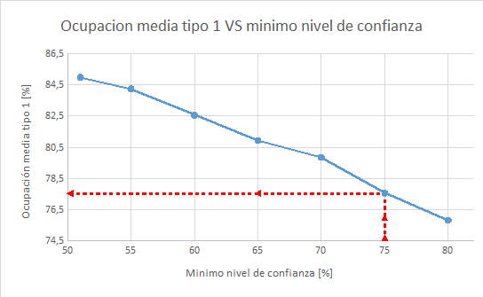

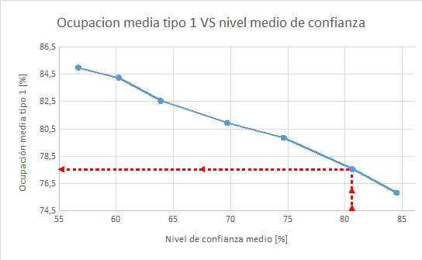

|  |  |  |
| --- | --- | --- |
| Confi min | Confi media | Ocup. media |
| 51 | 56,67 | 84,96 |
| 55 | 60,21 | 84,23 |
| 60 | 63,87 | 82,54 |
| 65 | 69,70 | 80,92 |
| 70 | 74,64 | 79,84 |
| 75 | 80,61 | 77,55 |
| 80 | 84,49 | 75,82 |